Teppanyaki Vegetables

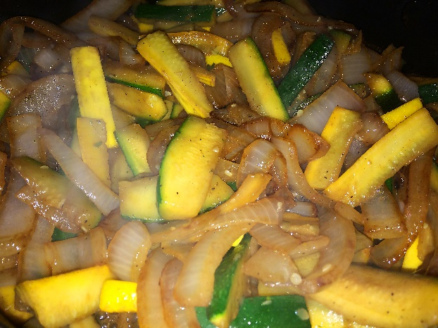
Ingredients:
1 Large Yellow Onion
4 Green and/or Yellow Zucchini
2 Tbsp Butter (can substitute Coconut Oil, if desired)
Ground Black Pepper to taste
¼ Cup Low Sodium Veri Veri Teriyaki® Sauce
Instructions:
- Chop entire onion and all zucchini into 1-inch-long pieces.
- Heat butter in a large non-stick pan over medium heat. (If using coconut oil instead, vegetables might not brown as easily.)
- Once all butter is melted, add the chopped onion to the pan and sauté for a few minutes until lightly browned.
- Add chopped zucchini to the slightly sautéed onion, sprinkle with ground pepper, stir occasionally until the onions are completely browned and the zucchini is tender.
- Pour Veri Veri Teriyaki® sauce over the vegetables, stir until completely covered, transfer to a serving dish and enjoy!
Makes about 4 servings

RubysNextBestThing.com

