Cheesy-Jalapeno Popper Chicken

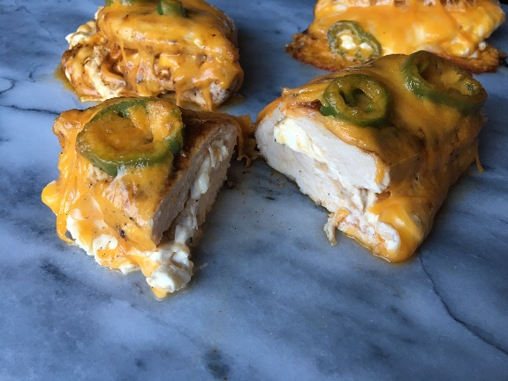
Ingredients:
Chicken Cutlets
Cooking Spray
Taco Seasoning
Salt
Black Pepper
Shredded Cheddar Cheese
Cream Cheese, plain
Jalapenos
Cheddar Cheese Slices
Instructions:
- Preheat oven to 400 degrees F.
- Heat medium non-stick skillet over high heat. Coat with cooking spray.
- Season chicken on all sides with taco seasoning, salt and pepper. Turn skillet down to medium and brown each piece of chicken on both sides.
- Remove chicken from skillet and place onto a baking sheet that is coated with cooking spray.
- Spread 1-2 scoops of cream cheese on half of each chicken, top with shredded cheese, and fold in half so chicken is covering cream cheese completely.
- Cut up the jalapeno into slices and place on top of chicken. Top Jalapeno slices with 1-2 slices of cheddar cheese to cover chicken once melted.
- Repeat steps 5-6 for all pieces of chicken.
- Place baking sheet in the oven and bake for 15 minutes or until chicken is cooked through completely! Remove from oven and enjoy!
RubyNextBestThing.com

