Mango Acai Bowl

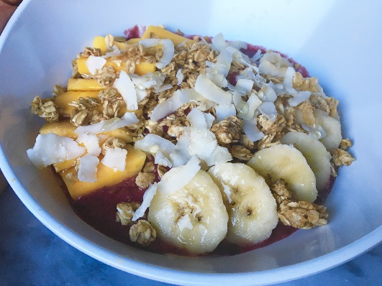
Ingredients:
½ Cup Frozen Mango, chopped
½ Cup Frozen Strawberries
½ Frozen Banana
½ Cup Unsweetened Vanilla Coconut Milk
1 Tbsp. Chia Seeds
2 Tbsp. Acai Powder
2 Tbsp. Shaved Coconut
1 Tbsp. Agave Honey
Granola
Extra Shaved Coconut
Extra Honey
Fresh Mango, chopped
½ Fresh Banana, chopped

Instructions:
- In a blender, combine frozen mango, strawberries, banana, coconut milk, chia seeds, acai powder, shaved coconut and honey. Blend until completely mixed together with no frozen fruit chunks remaining.
- Pour acai mixture into a bowl.
- Top with granola, coconut, honey, mango and banana pieces. Enjoy!
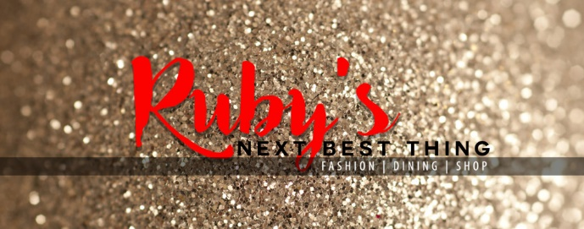
RubysNextBestThing.com

